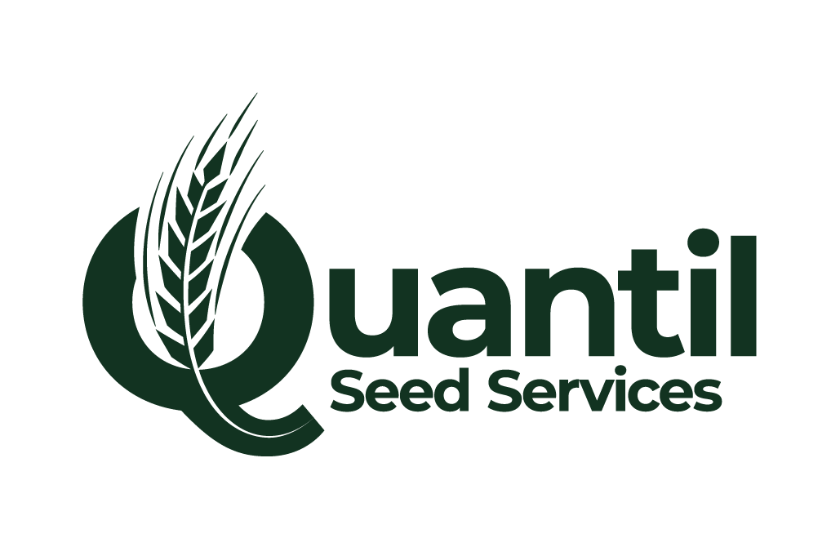
7th JULY 2025
C2 AUTUMN 2025 AVAILABILITY LIST
WHEAT | STATUS
KWS SOLITAIRE | AVAILABLE
KWS ARNIE | SOLD OUT
RGT HIGHGROVE | AVAILABLE
LG BEOWULF | AVAILABLE
BAMFORD | AVAILABLE
KWS DAWSUM | AVAILABLE
LG TYPHOON | LIMITED
KWS EXTASE | AVAILABLE
GRAHAM | AVAILABLE
2 ROW BARLEY
KITTY | LIMITED
RUSSO | AVAILABLE
ORGANA (BYDV TOLERANT) | LIMITED
LG CARAVELLE | AVAILABLE
KWS TARDIS | AVAILABLE
VALERIE | AVAILABLE
HYBRID 6 ROW BARLEY
SY QUANTOCK | AVAILABLE
SY KESTREL (BYDV RESISTANT) | AVAILABLE
SY CANYON | AVAILABLE
OATS
MASCANI | AVAILABLE
CROMWELL | AVAILABLE
TRITICALE
LUMACO | AVAILABLE
OTHER VARIETIES AVAILABLE ON REQUEST
All seed is sold subject to satisfactory certification and being unsold at the time of the order
For all enquiries please contact:
JOHN PAPE – 01695 586100 / 07590 607859 / john.pape@quantil.co.uk
ROSS DOCHERTY – 01695 586100 / 07468 432214 / ross.docherty@quantil.co.uk

