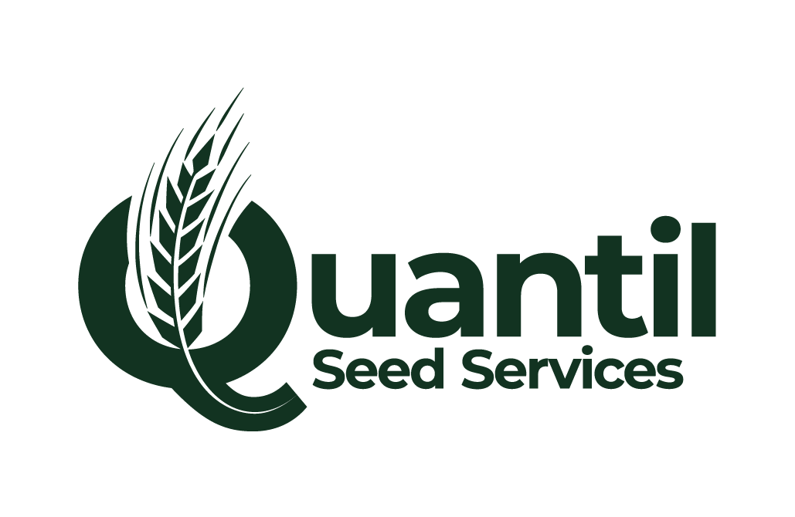
C2 SPRING 2026 AVAILABILITY LIST – 5TH NOVEMBER
Spring Barley | Stock status
NOS GAMBIT (NEW!) | AVAILABLE
LAUREATE | AVAILABLE
SKYWAY | AVAILABLE
LG DIABLO | AVAILABLE
RGT PLANET | AVAILABLE
Spring Wheat
OPHELIA | LIMITED
EVERLONG | LIMITED
WPB MYLO | LIMITED
KWS LADUM | LIMITED
Spring Oats
MERLIN | AVAILABLE
Winter Oats
CROMWELL | 30t - SPD
Spring Beans
GENIUS | AVAILABLE
LYNX | AVAILABLE
Spring Peas
KACTUS | LIMITED
Arable Silage Mix
60% Barley / 40%Pea | AVAILABLE
30% Barley / 30% Oat / 40% Pea | AVAILABLE
60% Pea / 40% Barley | AVAILABLE
50% Barley / 50% Pea | AVAILABLE
BESPOKE | AVAILABLE
Bird Feed Mix
Supplementary Bird Feed (AB12/AHW2) | PLEASE ENQUIRE

‘All seed is sold subject to satisfactory certification and being unsold at the time of the order’
For all enquiries, please contact either:
JOHN PAPE – 01695 586100 / 07590 607859 / john.pape@quantil.co.uk
ROSS DOCHERTY – 01695 586100 / 07481 776725 / ross.docherty@quantil.co.uk

